2020 CYCLE 16 AGM MINUTES
Wed., Oct. 21, 2020
Zoom Videoconference

- Call to Order: 7:03 pm
- Acknowledgement:
Greg Brown acknowledged that we are on the unceded territory of the Wet’suwet’en and specifically, the Gidimt’en clan’s territory.
- Appointing Chairperson:
Tony moved, Dan seconded that we appoint Greg Brown chairperson. Passed.
- Quorum confirmed: 17 attendees, which included all six board members
- Approval of Agenda
Tony Harris moved, Tracy McIntyre seconded that the agenda be approved. Passed
- Approval of 2019 Minutes
Dan Boissevain moved, Tony Harris seconded that the 2019 AGM minutes be approved. Passed.
- Director’s Reports:
President’s report: Tony thanked current and past directors, as well as numerous donors and supporters, highlighted progress to date and outlined anticipated next steps. All going well, we could potentially have a trail built by this time next year. (See Appendix A for details).
Tony clarified for Al Campbell the endpoint of Phase 1 of the trail. Janet Harris pointed out that the Rotary Club of Smithers should be included as being very big, ongoing supporters. Greg added that it was Rotarian Jos Konst, who recently passed away, that got Greg very excited a few years ago about the prospect of the trail.
Financial Report: John Bakker presented the financial statement for the year ending
Dec. 31, 2019. Items of significance included receiving a number of grants and donations, payment for the Par 3 Right of Way, consulting fee payment to McElhanney, maintenance report payment to Lilliana Dragowski, and Strategic Planning payment to Bachrach Communications. (See Appendix B for details).
- Election of Directors:
All current members of the Board were willing to stand in their current positions. Allan Cormier and Sue Harrison were additional nominees for Director at Large – filling a vacant position and adding one more to the roster. All nominees were elected by acclamation.
President: Tony Harris
Vice-president: Jeremy Shriber
Secretary: Mary Brise
Treasurer: Janet Harris
Directors at large (4): Dan Boissevain, Allan Cormier, Sue Harrison and Alison Watson.
Jeremy moved, Janet seconded to accept the candidates by acclimation. Passed.
- Adjournment:
Dan moved, Tracy McIntyre seconded that we adjourn. Passed
Meeting adjourned at 7:31 pm.

Respectfully submitted,
Mary Brise, Cycle 16 Secretary
Appendix A – October 21, 2020 AGM
President’s Report – Tony Harris

I’d like to recognize we are on the traditional territory of the Wet’suwet'en.

First off, I’d like to express my sincere thanks and appreciation to the Board members, Janet, Mary, Alison, Dan, Jeremy who, along with others, have worked tirelessly these past 5 years. We have learned a great deal through the process and are experiencing the pleasures of being in a functional and effective team. Also, a huge sigh of gratitude to John Bakker who has recently stepped up to the plate and taken over our financial recordkeeping.

Thanks also to past Board member, Jill Dunbar, who resigned earlier this year. Jill was instrumental in setting up our structure as a society. There are many others who have played a part in helping us get this far along the trail building process. In particular Dale Perry of Perry & Company and Gina Hidber of HBH Land Surveying and, of course, Greg Brown who stepped down from our Board when he became a town Councillor. We also thank the many people who have carried us along with their many positive comments.

We continue to work in collaboration with our stakeholders:
The Village of Telkwa The Town of Smithers The Regional District of Bulkley-Nechako, the Office of the Wet'suwet'en and MOTI, who along with the Regional District have both been particularly helpful in the process.

Thank-you to the following funders:
Huge thank-you to Kassandra Trust who has donated $52,000, which has enabled us to acquire two right-of-ways. We’ve had tremendous support from local business. Thanks go out to LB Paving, Logpile Lodge, Rustica Bakery, Nature’s Pantry, Hy-Tech Drilling, and Seabridge Gold. We’ve also received many donations from individuals and would like to thank everyone who has made donations large or small. In particular, we’d like to thank Ali Howard, Al Gamble, Caron Procak, Shawn Kennedy and various anonymous donors.

What has happened over the past 12 month
- signed on WSP as our project managers. Allan Kindrat is representing WSP and we’d like to complement him on the forward momentum that he’s created in the short time with us.
- A signed MOU (Memorandum of Understanding) with the Regional District around the ownership issue.
- Increased our membership in excess of 300 new members. We reached our goal of 1000 members in early July and continue to grow. Our present membership count is 1065
- Ran a successful fundraising campaign, connecting the cycling community through the Tour de Croissant events this summer. About 1500 people attended the weekly events.
- Completed the ROW through the Tersago property.
- We sold many t-shirts and have a new t shirt design which feature’s Facundo Gastiazora’s bear on a bike design. A big thank-you to Sue Harrison for coordinating the t-shirt sales.
- Survey highlights: 588 respondents; overwhelming support for the trail and the safety it would provide; 87% were interested in using the trail for fun, followed by fitness and then socializing.
- Flywheel is starting to move - it took 7 of us to get the one revolution out of the wheel and this year all of us pushing together got the wheel spinning several revolutions. Imagine next year if we keep this up.

What We Need To Do In The Next 6 Months
Charity Status
Mary, who started this process with Jill, has been working like a hound dog trying to get our charity status. It is a bit of an exercise of patience, especially with COVID, but we are slowly getting there.
Detailed Construction Drawings
We hope to get started on these and have them ready for tendering in the Spring.
Geotechnical work is due to start shortly, possibly as soon as next week.
MOTi (Ministry of Transportation and Infrastructure)
Will provide the permit to build once the Construction Design is completed
Regional District
finalize ownership of the trail
ALR (Agricultural Land Reserve)
Regional District has made application to the ALR for the trail in the Highway RoW and a team is going out this weekend to do soil testing, which is needed to finalize RoW through private land.
Fundraising
We are in the process of applying for funding in excess of $1,000,000 from a COVID relief fund.
Trail Maintenance Costs
Several businesses and individuals have been approached to see if they might be interested in providing either in-kind donations or money to offset the expected annual maintenance costs. We are also exploring the idea of starting a trust with the hope it will have enough assets to cover these costs far into the future.
Cycle 16 memberships
We will continue to attempt to attract new members. The larger our membership, the louder our voice.
Political Support
We are now on the Political agenda with all 4 local candidates for the provincial election publicly expressing support for the project
Construction
If we get the required permits, the funding falls into place etc., we hope to begin construction of Phase 1 in 2021. If all goes well, who knows, we may have a trail by this time next year.

Respectfully submitted,
Tony Harris,
Cycle 16 President

Appendix B – October 21, 2020 AGM
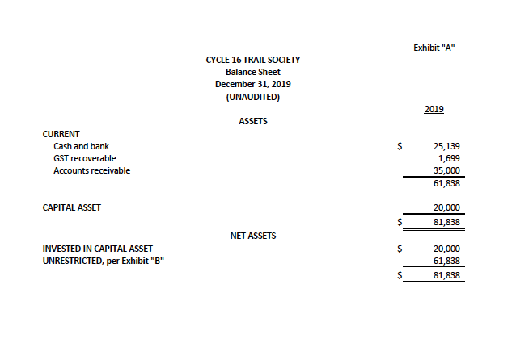
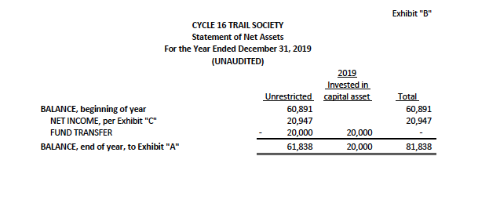
Financial Statements – John Bakker

Respectfully submitted,
John Bakker, CGA (retired)
Volunteer Cycle 16 Accountant

